Project Demonstration
Demo Video: comic_ai.mp4 – Google Drive
https://drive.google.com/file/d/1OSdXAdiR2g9xLpy8JClDPbm-6xnLYRdn/view

Demonstration Screenshots
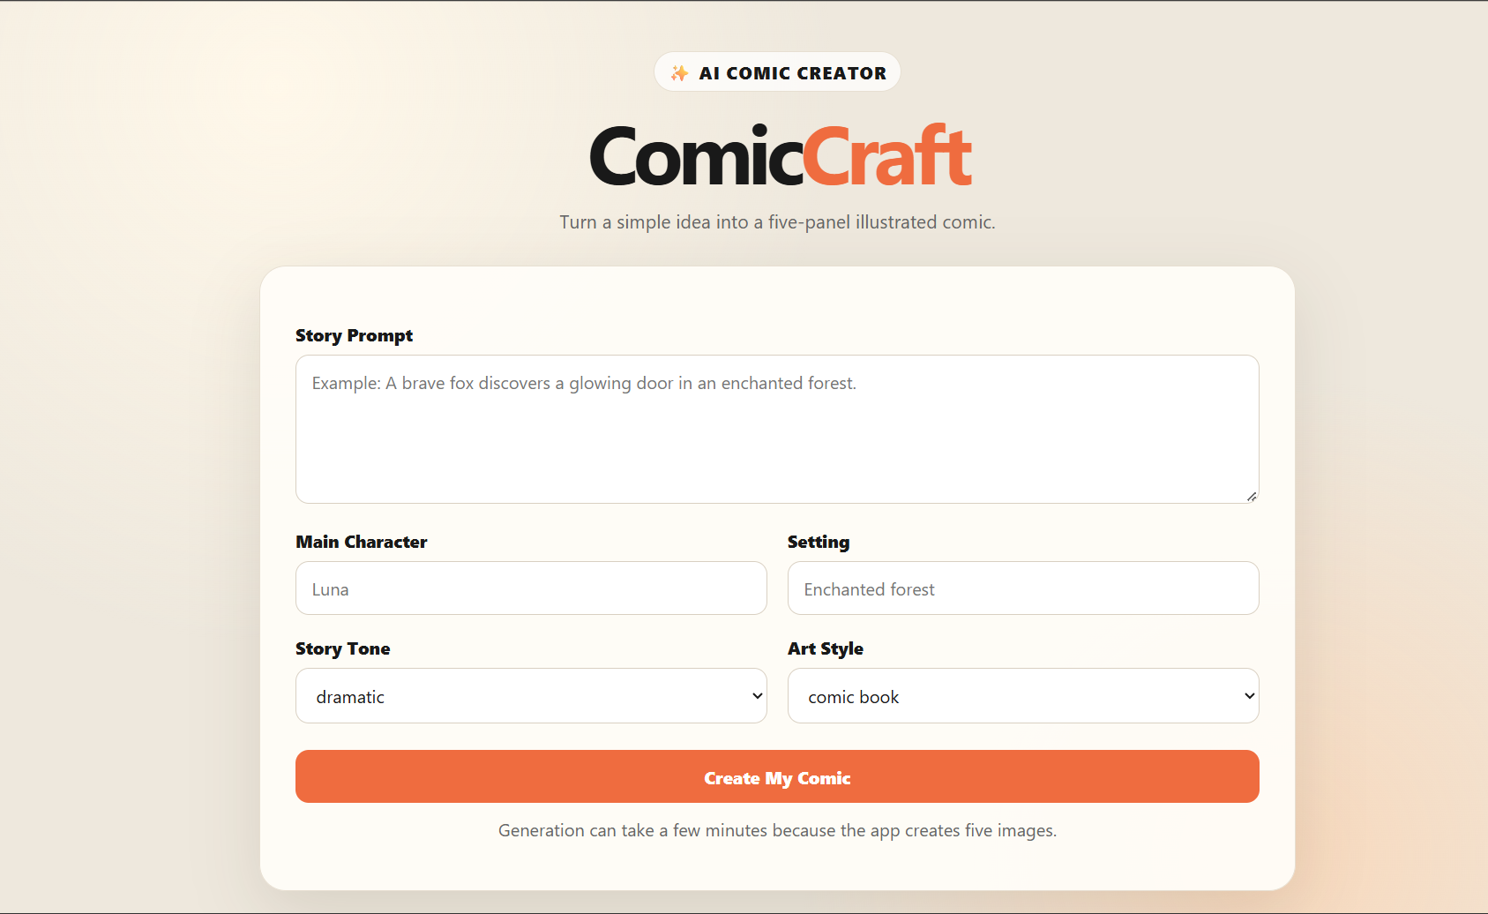
1. ComicCraft Homepage
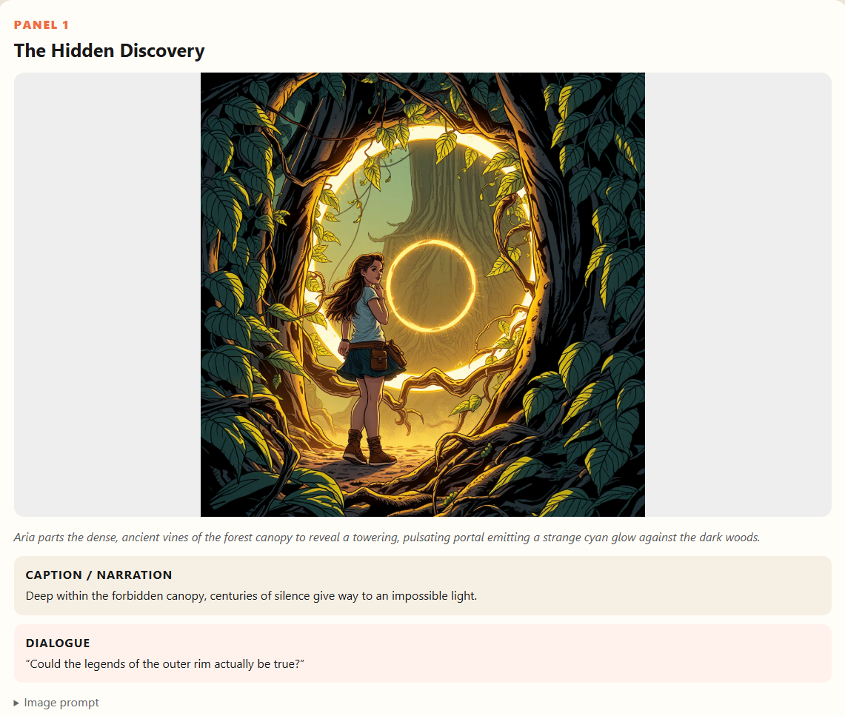
2. Comic Preview – Panel 1
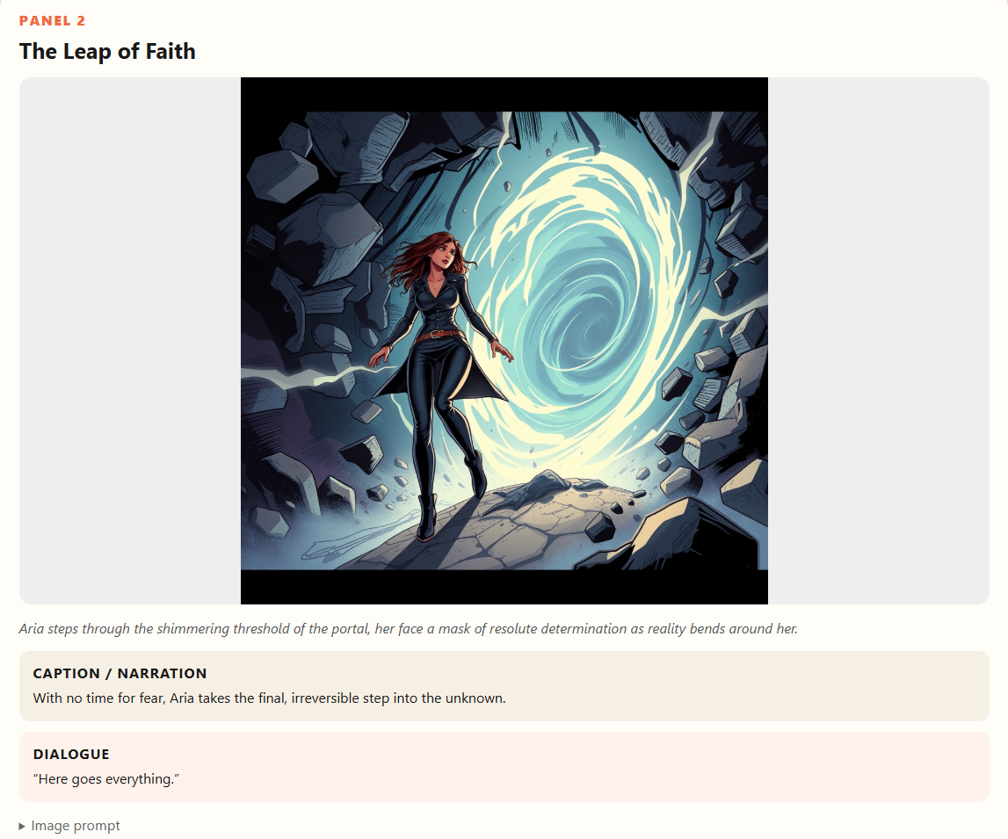
3. Comic Preview – Panel 2
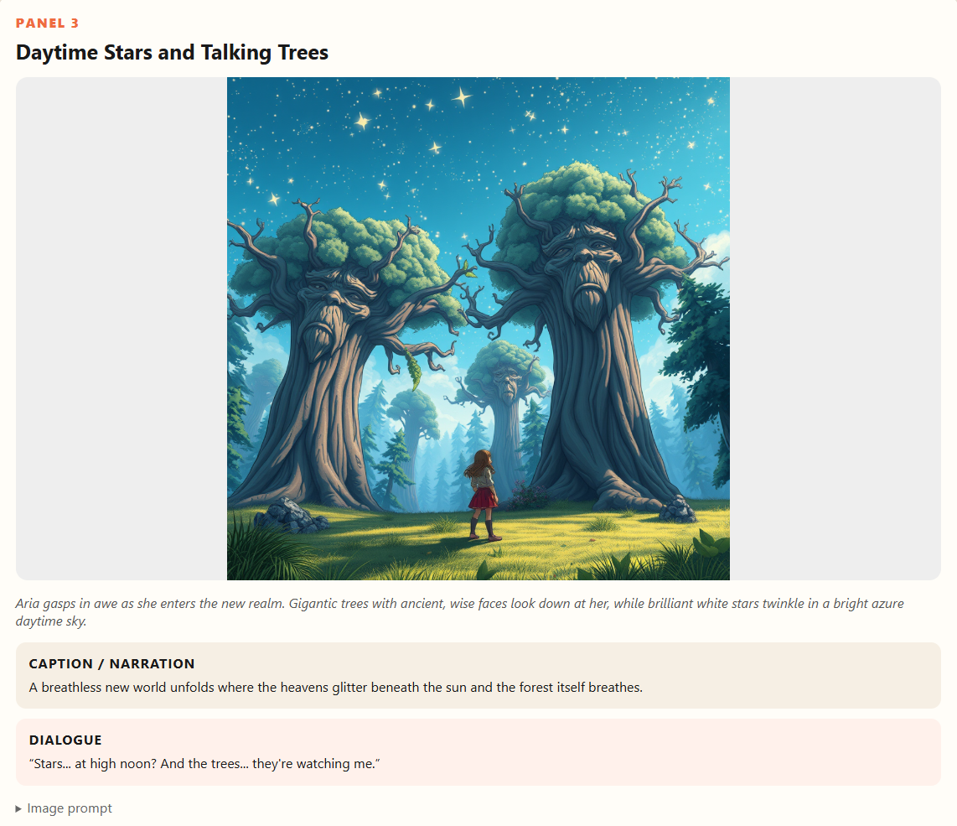
4. Comic Preview – Panel 3
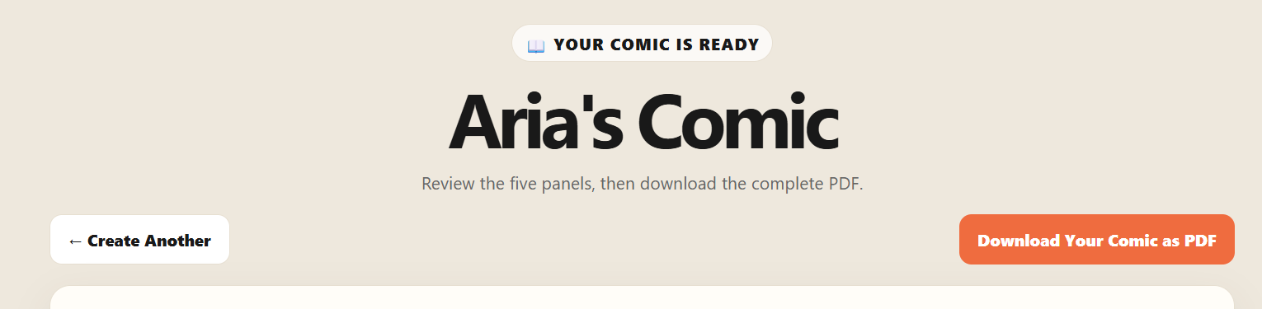
5. PDF Download
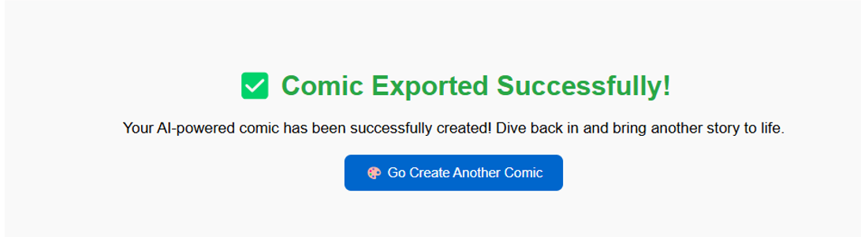
6. Export Success
The demonstration shows the user journey from the ComicCraft homepage through comic preview and PDF export.

